ASTRONOMY 206.2 GENERAL ASTRONOMY II

“Solutions” Sheet Student Name

Laboratory Exercise 16. The Absolute Magnitude of a Quasar

Purpose. To determine the absolute magnitude, i.e. luminosity, of the quasar 3C273 from its spectrum, and to examine its variability.

Procedure. See Laboratory Manual.

Equipment.

- spectrum of 3C273
- image of the field of 3C273 from the Palomar sky survey
- graph paper

Data.

1. Distance to 3C273.

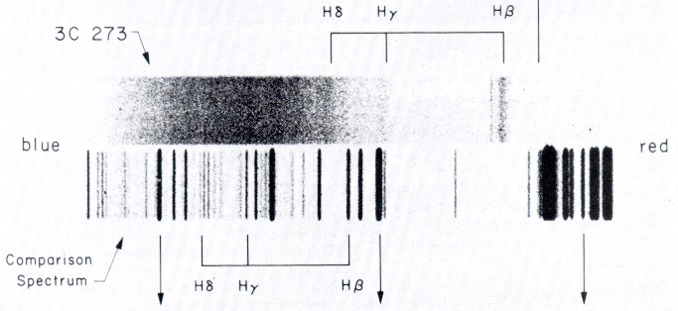

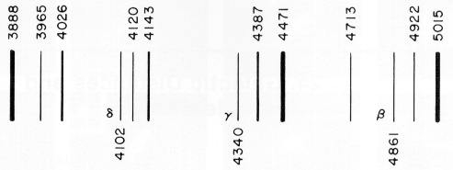

Measured Positions of Helium and Hydrogen Comparison Lines
Line | Wavelength, λ | Position (millimetres)
3888 | 3888.65 Å
3965 | 3964.73 Å
4026 | 4026.19 Å
4102 | 4101.74 Å
4120 | 4120.81 Å
4143 | 4143.76 Å
4340 | 4340.47 Å
4387 | 4387.93 Å
4471 | 4471.48 Å
4713 | 4713.14 Å
4861 | 4861.33 Å
4922 | 4921.93 Å
5015 | 5015.67 Å

Scale of spectrogram (in Å/mm) from attached graph† =
(† Make the graph yourself and append it to the lab write-up.)

Quasar Line | Hβ, 4861.33 Å | Hγ, 4340.47 Å | Hδ, 4101.74 Å
Position (millimetres)
Calculated Wavelength, Å
Wavelength Shift, Δλ
Recessional Velocity, v

Line Velocities Calculated using 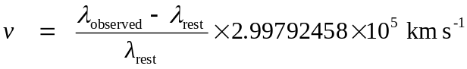

Average velocity of recession, v = km/s ± km/s

Calculated distance to 3C273: 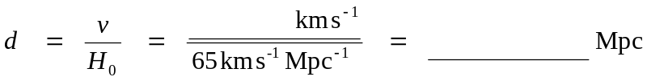

2. Luminosity of 3C273.

Star | Apparent Magnitude, m | Measured Diameter, d (mm)
a | 12.5
b | 13.1
c | 12.1
d | 12.6
e | 13.2
f | 12.8
g | 13.7
h | 14.0
3C273 | ?

Insert a graph of measured diameter, d (in millimetres) as a function of apparent magnitude, m.

Estimated magnitude of 3C273 from Graph, m =
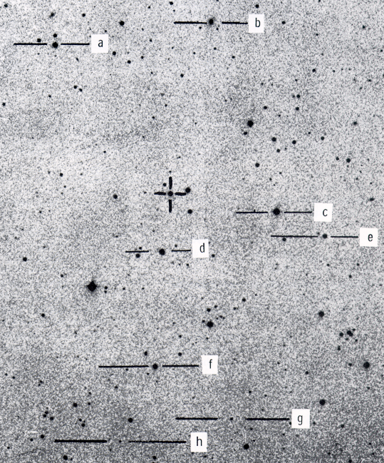

Absolute Magnitude of 3C273:

Calculations:

Comparison with various astronomical objects and comments on energy output of 3C273:

3. Variability of 3C273.

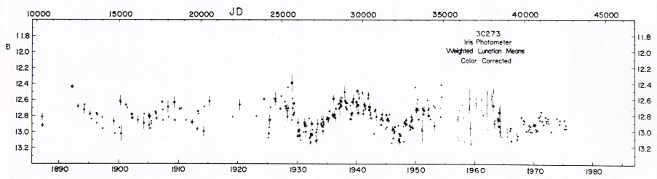

Estimated Period of Variability of 3C273, P =

Estimated size of 3C273:

Calculations:

Comments:

Discussion.

Conclusions.

